pantoxravtwr yDv

Pre-Biblical Revelation (#9)

Author: Ron Banuk Site: Grace Chapel
Date: Sunday, 15 March 2009

Almighty

Romans 1:19-20 NLT

19 For the truth about God is known to them instinctively. God has put this knowledge in their hearts.
- 20 From the time the world was created, people have seen the earth and sky and all that God made. They can clearly see his invisible qualities--his eternal power and divine nature. So they have no excuse whatsoever for not knowing God.

God’s Creation Speaks (Ps 19 NLT)
- The heavens tell of the glory of God. The skies display his marvelous craftsmanship.
- Day after day they continue to speak; night after night they make him known.
- They speak without a sound or a word; their voice is silent in the skies;
- yet their message has gone out to all the earth, and their words to all the world.

Agenda

- Protoevangelium & Mazzarot

- Early Biblical Archaeology & Legends

- Chinese Characters

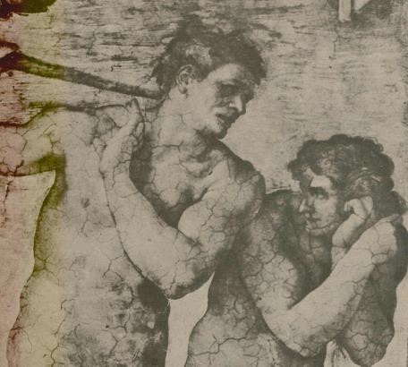
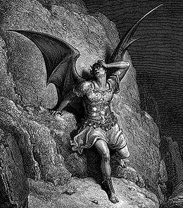
Primal Revelation

Gustave Doré 1832-1883
Paradise Lost

Protoevangelium
{God is judging Satan while Adam and Eve listen.}
{This is the second of Satan’s seven judgments.}
{This is midway into the Adamic Covenant.}

Michelangelo 1475-1564 Temptation Scene Sistine Chapel

- And I will put enmity between you and the woman,{Irony, flood}
- And between your seed and her Seed; {Anti-Christ and Messiah}
- He shall bruise your head, {Cross, Mid-Trib, Millennium, GWTJ, Lake of Fire}
- And you shall bruise His heel. {at Crucifixion}
She…Her DR They…Their MT It…His KJV
It…Its NJB
He…His NKJV
He…His NAB
- Genesis 3:15 NKJV

- Note: First Judgment: Ez 28:16 Cast from the Mt of God Second Judgment: Ge 3:14 On your belly you shall go

Eve’s Knowledge of Messiah
  - Now the man had relations with his wife Eve, and she conceived and gave birth to Cain, and she said, "I have gotten a manchild with the help of the LORD.“—Genesis 4:1 NASU
manchild: ish is translated 1426 times as “man” and once as “manchild”.
LORD: YHVH
  - Eve knew God would send a Messiah.

  - She knew he would be divine………

(O)

  - She thought her first-born was the Messiah.

Ref: Kang 1994, p 39, 43, 45, 77, 101 {son + divine = seed} . Fruchtenbaum #12.

Ecliptic vs Celestial Equator
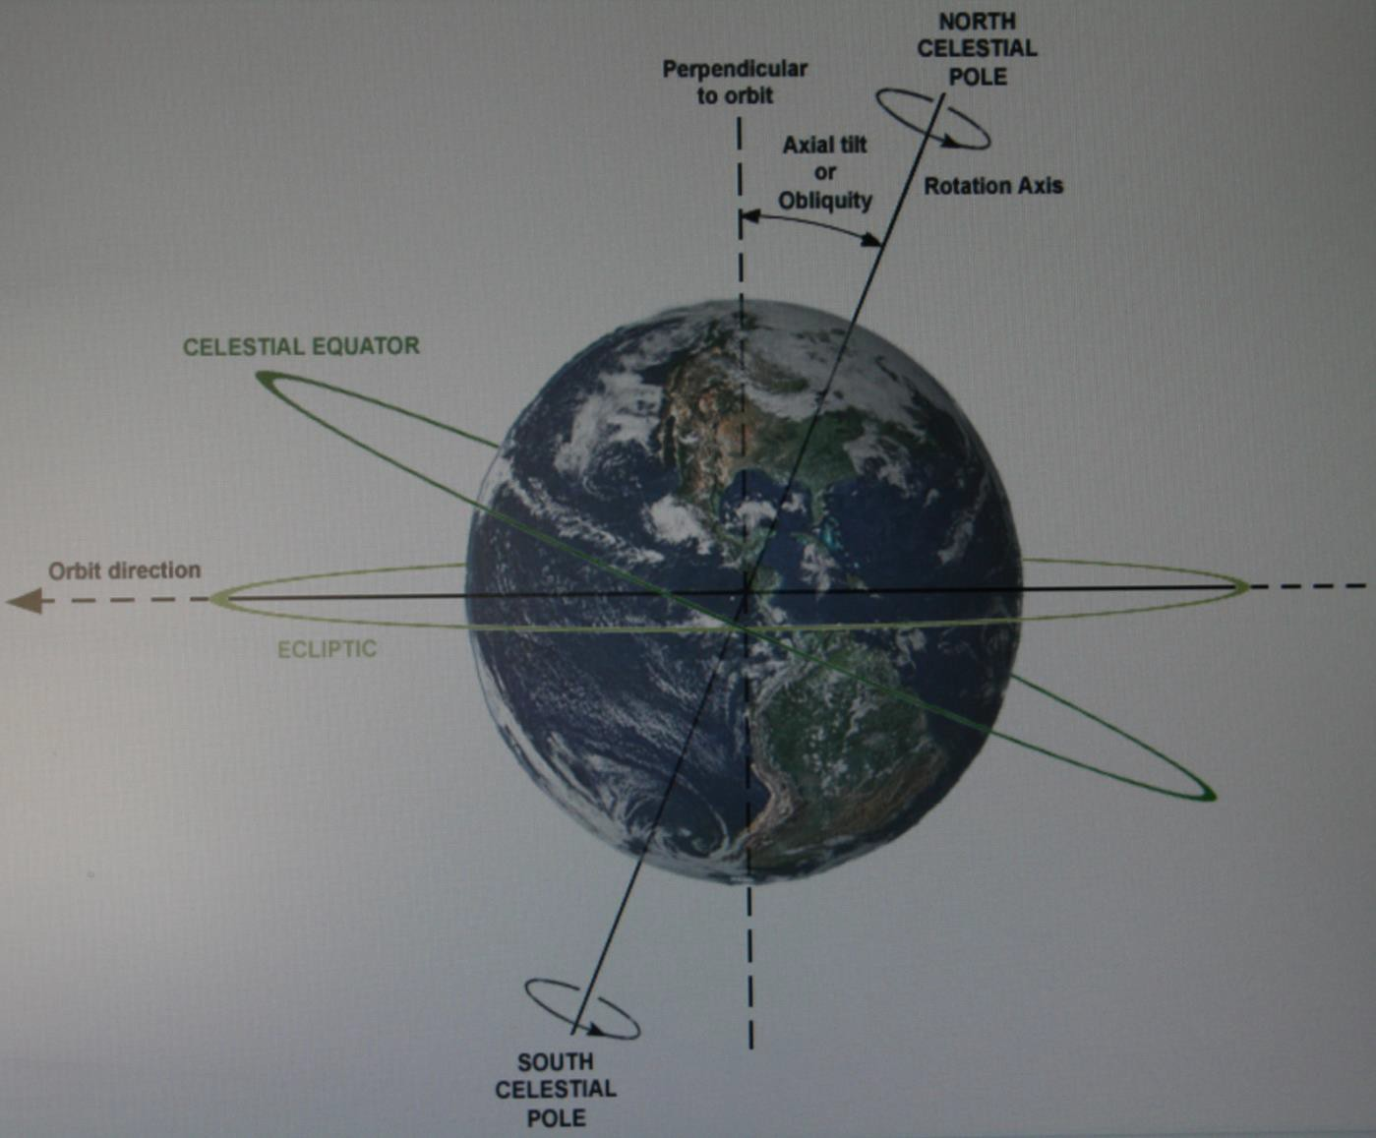

Leading Constellation Researchers

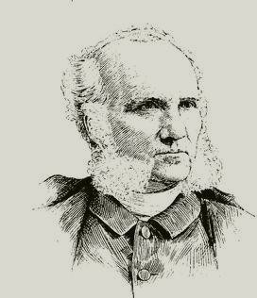
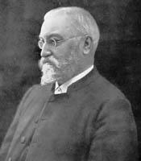
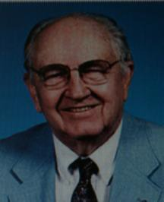

No Picture

Frances Rolleston 1781-1864
Christian Scholar Mazzaroth (1862)
Joseph A. Seiss 1823-1904
Lutheran Theologian Maryland Gospel
In the Stars (1882)
E.W. Bullinger 1837-1913 Anglican
Dispensationalist Kent, England Witness
Of the Stars
(1893)
Henry M. Morris 1918-2006
Evangelical Christian
Creation Research Biblical Basis for Modern Science (1984)
D James Kennedy 1930-2007
Presbyterian Coral Ridge Hour Florida
Real Meaning of The Zodiac (1989)
Chuck Missler c 1940-Present Koinonia House
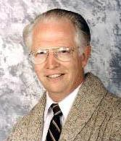
Coeur d’Alene Idaho Signs in the Heavens (1999)

John P. Pratt c 1940-Present
LDS
Astronomer Lost Constellation Testifies of Christ
(2001)

What is Your Sign?
- 12-22 →1-19 Capricornus Death to the Sea Goat
- 1-20 →2-18 Aquarius Waters cleansing the Earth
- 2-19 →3-20 Pisces The fish or people of God
- 3-21 →4-19 Aries The Ram reigning
- 4-20 →5-20 Taurus The Bull returning
- 5-21 →6-21 Gemini The twins, Son of Man & Son of God
- 6-22 →7-22 Cancer The crab as the retainer of the sheep
- 7-23 →8-22 Leo The lion of the tribe of Judah

- 8-23 →9-22 Virgo The Virgin
- 9-23 →10-23 Libra The scales of redemption
- 10-24 →11-21 Scorpio The Satanic forces of evil
- 11-22 →12-21 Sagittarius The archer as the Messiah

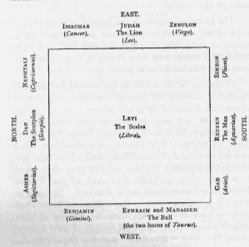
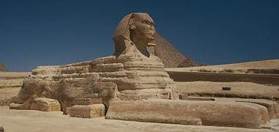
Mazzarot
- Virgo Promised seed of the woman
- Libra Scales of divine justice for redemption
- Scorpio Sting to be inflicted on the promised seed
- Sagittarius Corruption of the human race thru demons
- Capricornus Utter wickedness of mankind
- Aquarius Destruction of the world by flood
- Pices Emergence of the true people of God
- Aries Sacrifice of the Lamb of God

- Taurus Coming of the Ram as mighty Bull & Judge
- Gemini The dual nature of the reigning King
- Cancer Ingathering of the redeemed from all ages
- Leo Destruction of the Serpent by the King
Ref: Henry M. Morris, The Biblical Basis for Modern Science, Baker 1984, p 182

Deductive Process

Constellation Name

Biblical Knowledge
(Hebrew/Arabic/Egyptian)

Major Star Name (a,b,g,d))) Original
(Hebrew/Arabic/Egyptian) Meaning

Constellation Pictograph (Earliest Rendering)

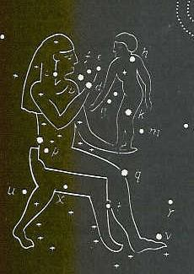
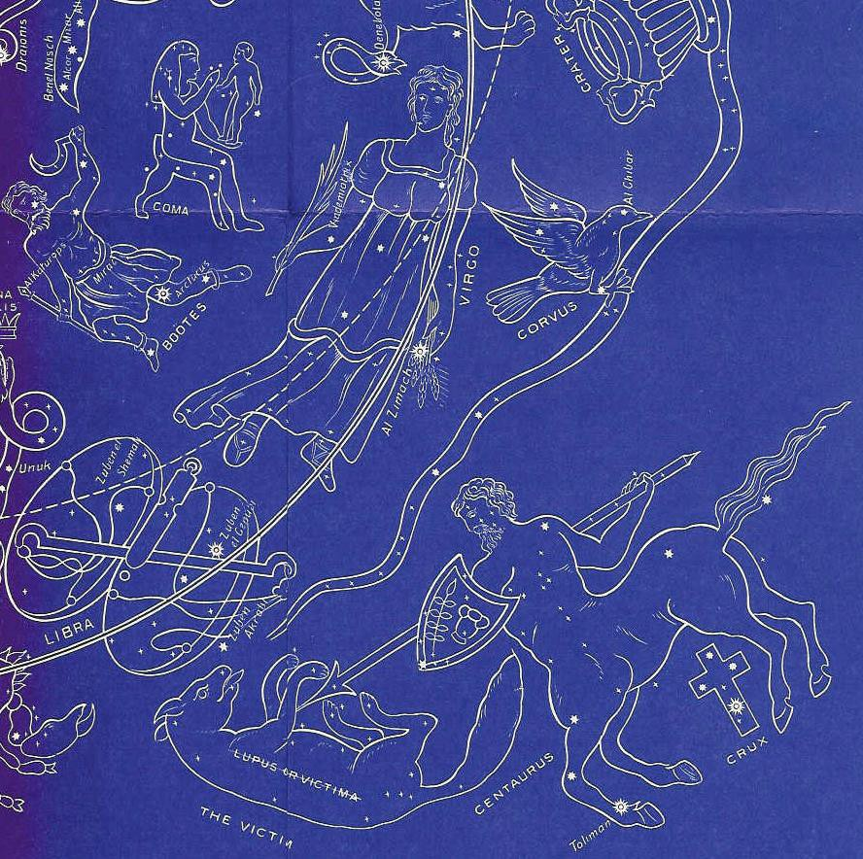Coma (Desire)

E.W. Bullinger 1837-1913 Anglican
Dispensationalist
Shes-nu=desired son Boy=Ihesu (850AD) Cor Christi:heart of C 43 Stars

Constellation: Virgo

Virgo (Betulah)
Tsemech/Al Zimach: Branch
Aspolia=Seed Vindemiatrix: Branch coming
110 Stars
Ge 3:15, Is 7:14, Jer 23:5
almah parthenos
Centaurus
Bezeh=Al Bezr=Despised Asmeat=Sin Offering Cheiron=Pierced
35 Stars
Boötes
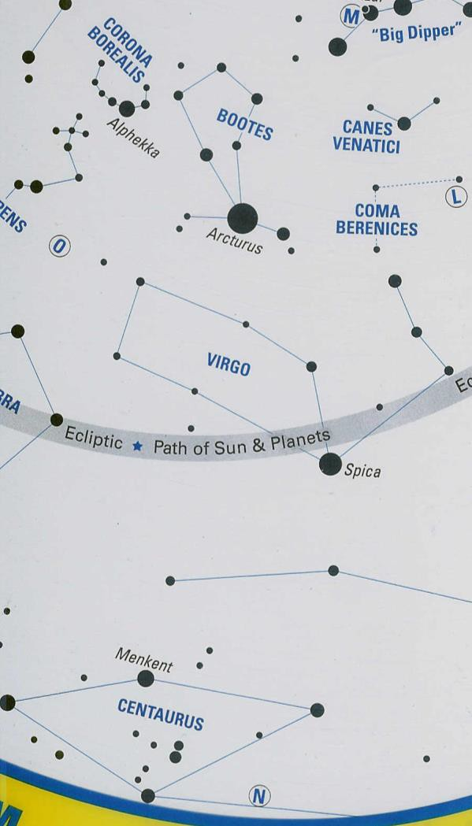Bo=to come Arcturus: He Comes Smat=He Rules Katurops=Branch Nekkar: was Pierced 54 Stars

Ptolemy (100-170 AD)
Albumazar (786-886 AD)
48 Ancient Constellations

Virgo, Libra, Scorpio

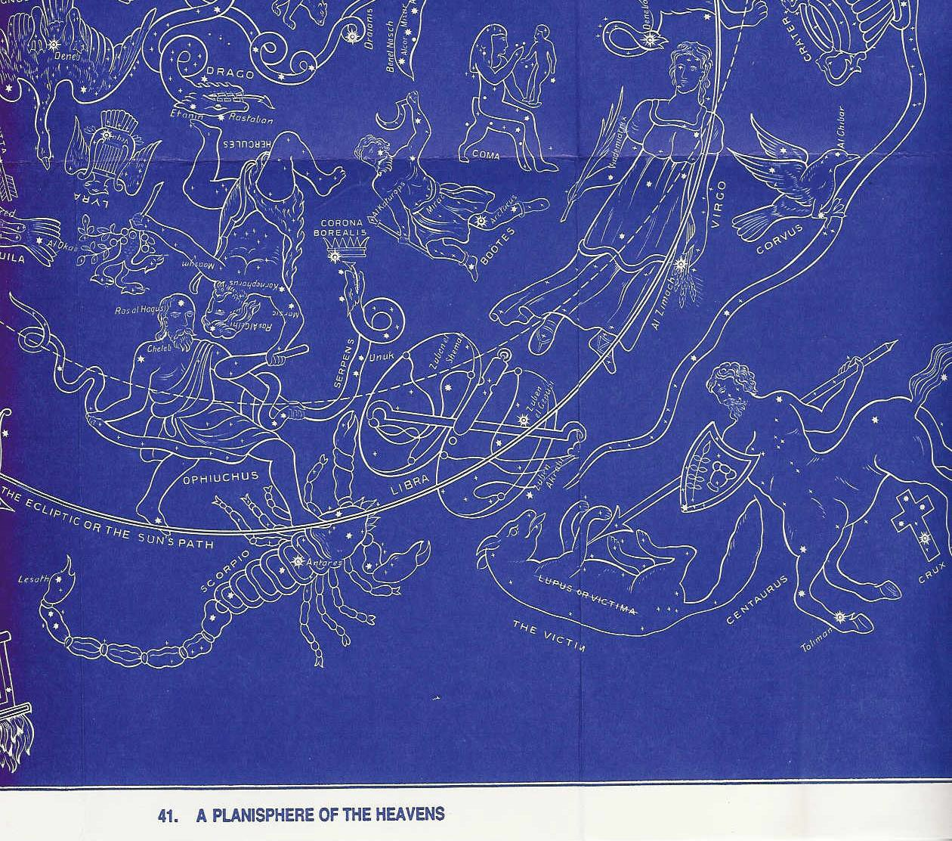
The Virgin with the Branch delivers the Seed of the Branch. Is 7:14

What is the price of Redemption told by the scales?
The Centaur of dual nature slays victim (himself) for offering on Cross. Jn 10:17-18

Ophiuchus bruises Scorpio’s head while He bruises his heel. He struggles with the Serpent intent on securing a crown.
Ge 3:15
B.C. Evidence Conclusion:
- gods to God
- God to gods

- No case

(Ref: E.W. Bullinger)

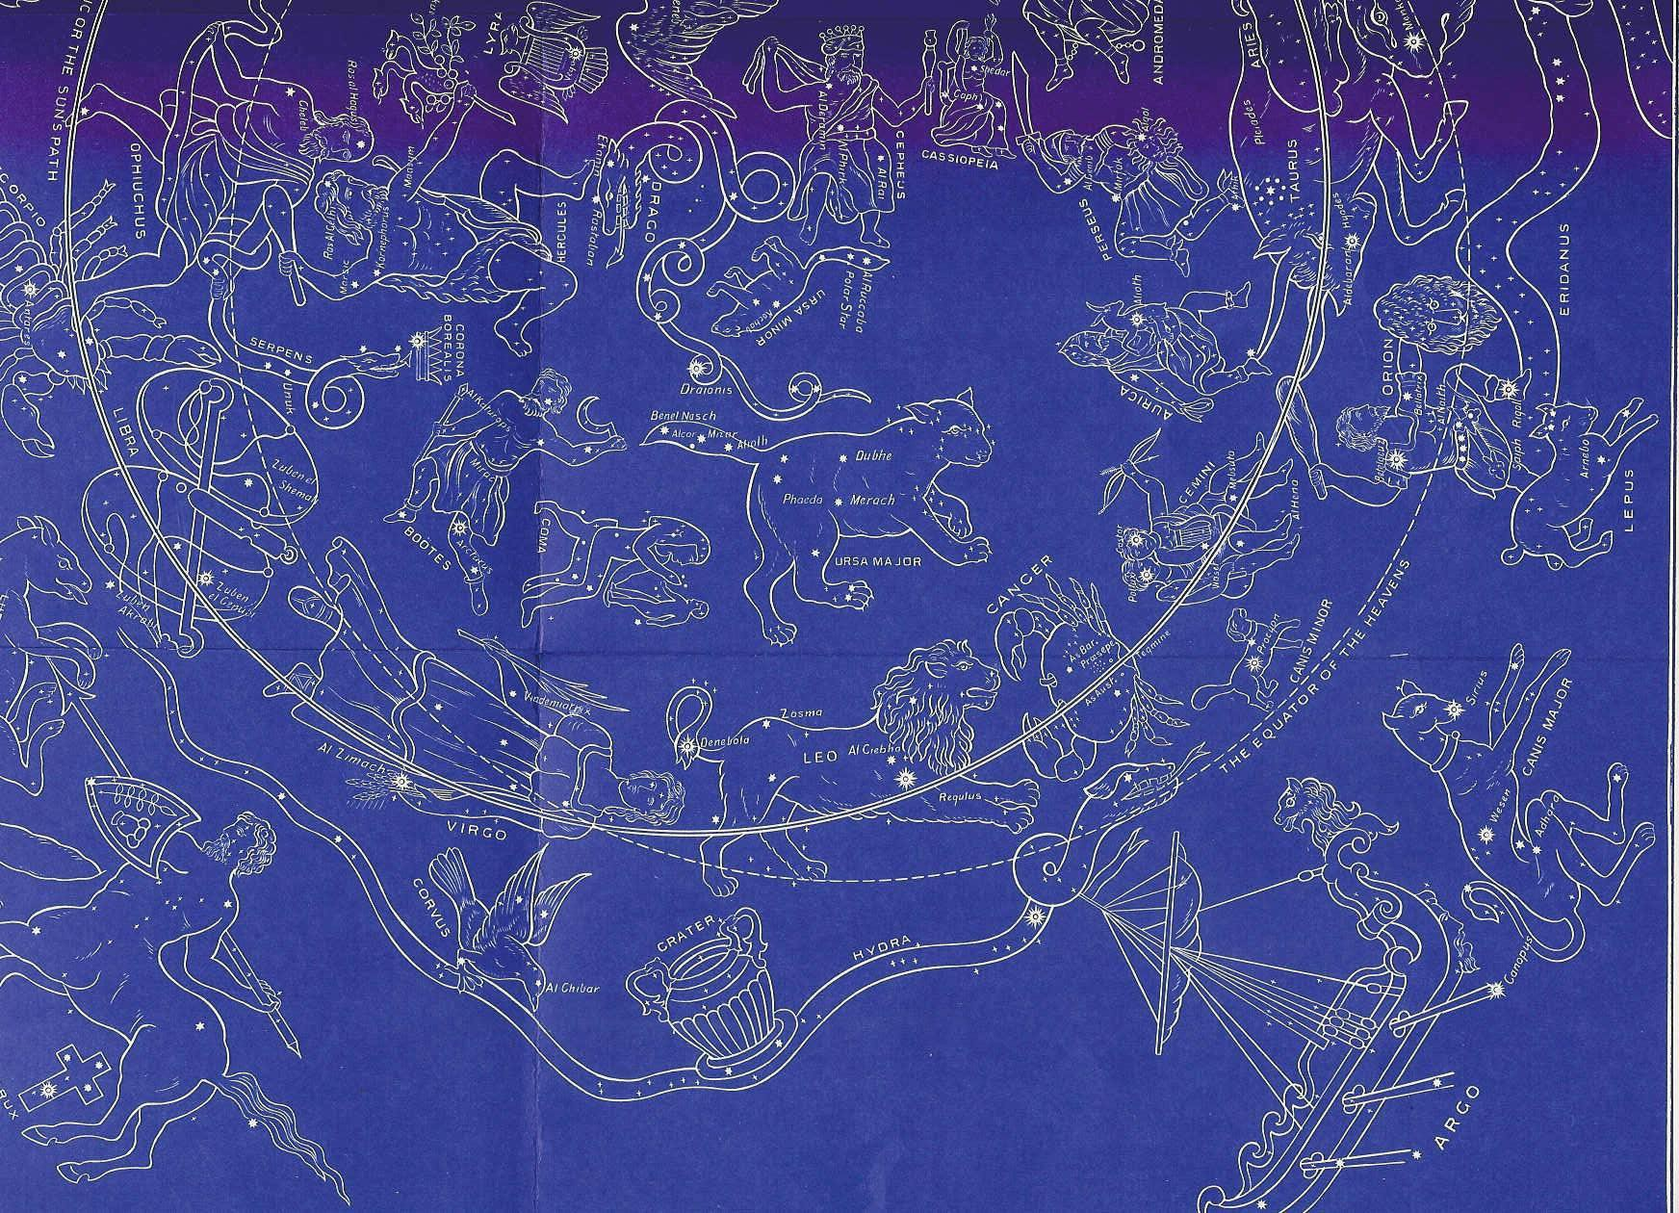
Taurus, Gemini, Cancer, Leo

Thuban

Mazzarot Explained
Virgo: The virgin bearing Branch and Seed delivers the desired Son (Coma) for all nations. He will come forth to rule (Boötes) with the crown (Corona) and yet be rejected for his dual nature (Centaur) as the despised (Al Beze) Sin Offering (Asmeath).
Libra: What is the price for Redemption told by the Scales (Libra). The Centaur of dual nature slays himself as the victim (Lupus) to offer on the cross.
Scorpio: Ophiuchus, the Messiah, bruises Scorpio’s head while Scorpio bruises his heel. He struggles with the Serpent intent on the crown (Corona).
Sagittarius: Sagittarius, the archer and chief centaur, conquers (Rev 6:2). Praise him with a harp on eagle’s wings. He pours the consuming fire from the altar as a curse on his enemies below. But still, the Dragon remains as the cynosure of the heavens.
Capricornus, Aquarius, Pisces, and Aries: Destruction of the world by Flood.
Taurus: Messiah the Bull comes forth. As Orion, the coming of the Branch (Betelgeus), he places his left foot over his enemy ,Lepus, at the River of the Judge, Eridanus. For all his wrath, he remains the good (Jn 10:11), great (Heb 13:20), and chief (1 Pt 5:4) Shepherd, Auriga.
Gemini: The Twins, Apollo the Judge and Hercules the suffering Servant, come as the mighty (Al Habor) Prince (Canis Major) and the burdened (Gomeisa) Prince (Canis Minor) to defeat the enemy, Lepus.
Cancer: He binds together those the Father has given him into a small sheepfold (Ursa Minor) [dohver
vs doher] and a large sheepfold (Ursa Major) from the company of travelers (Argo) in the ark.
Leo: The Lion of Judah, will tread underfoot (Regulus) the harlot (Hydra the female serpent) who sits on many waters (Rev 17:1) with her cup of abominations (Crater). She will be broken up (Her-na) by Corvus, the Raven, and be tread underfoot by Leo.
Interpretation showing the interaction of the Decans and some stars by Ron Banuk

Earliest Post-Flood Cities
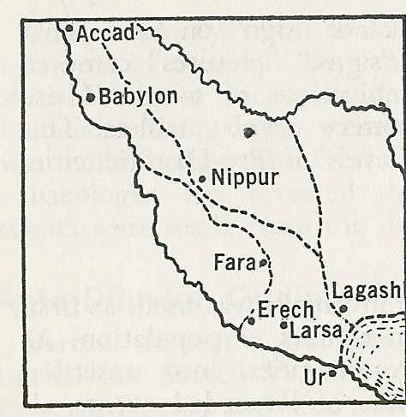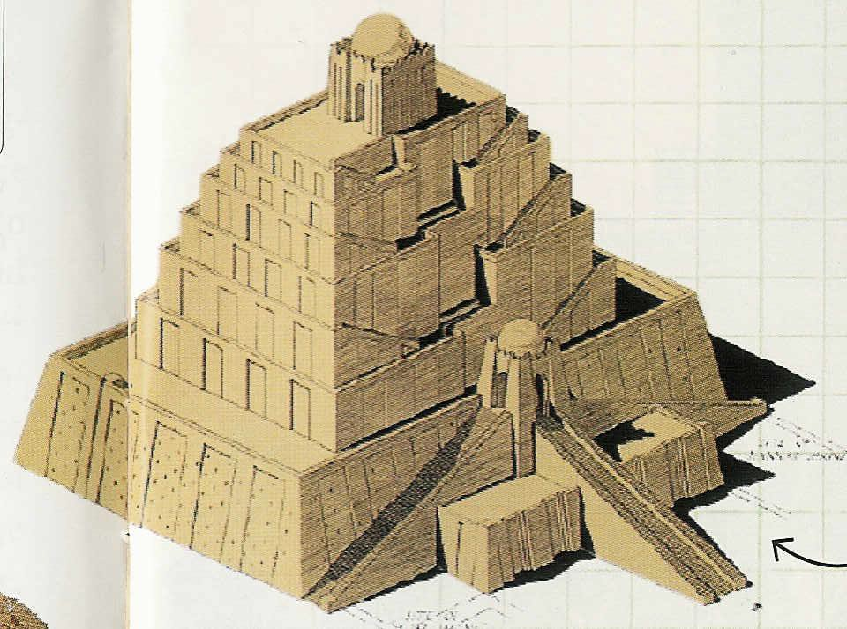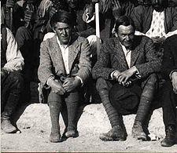10 The beginning of his (Nimrod) kingdom was Babel and Erech and Accad and Calneh, in the land of Shinar. 11 From that land he went forth into Assyria, and built Nineveh… Genesis 10:10-11 NASU Erech Urech Ur
Ref: Answers Magazine April—June 2008, p 29 Leonard Wooley Ziggurat at Ur
Tigris
Calneh
Ken Ham 1951-Present Answers Mag
Wooley Right 1880-1960
1st Modern Arch.
Euphrates

Ref: Halley’s, Rev 24, p 46

Cradle of Civilization

Akkadian Temptation Seal

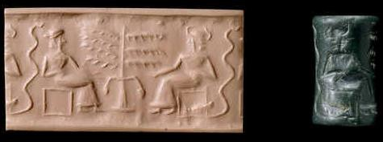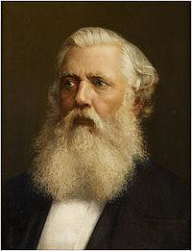It is changed like clay under the seal; Job 38:14 NAS

Ref: Adam and Eve Temptation Cylinder Seal made of Chlorite Greenstone. British Museum # 89,326. 1.5” inch tall. 2200 B.C. Discovered in Akkad of Sumer by Sir A.H. Layard who unearthed Babylon and Nineveh.

Sir A.H. Layard 1817-1894

Sumerian Adam and Eve Seal
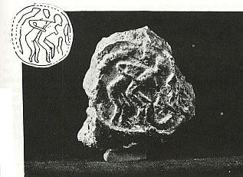

Ref: Adam and Eve Seal (1 Inch Diameter) in the University Museum at Philadelphia found in 1932 by Dr. E.A. Speiser 12 miles north of Nineveh
Dr. E. A. Speiser
1902-1965
Discovered Tepe Gawra

Babylonian Flood Story
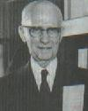
Adapa (Adam) was a blameless and wise man who offended the gods and became mortal thru knowledge. He no longer ate the Tree of Life and passed a sickness on to the people. The gods clothed him with a mourning garment.

Ref: Halley’s Bible Handbook, 25 Ed, Zondervan, 2000; p 97
Carl G. Rasmussen, Archaeology and History Note: See Mark Isaak for 265 flood stories:
www.talkorigins.org/faqs/flood-myths.html#Maya

Henry H. Halley
1874-1965
Transylvania U. Kentucky

Babylonian Flood Accounts
- Berosus, a Chaldean priest circa 290 B.C. related a tradition that Xisuthrus, the Babylonian Noah, buried the Sacred Writings before the Flood, on tablets of baked clay , at Sippar, and afterwards dug them up.

- There was a tradition among Arabs and Jews that Enoch invented writing, and left a number of books. An ancient Babylonian king recorded that “he loved to read the writings of the age before the Flood.”

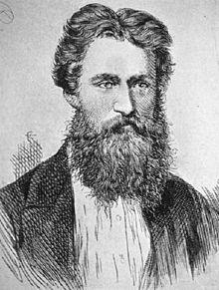
- Tablets discovered by George Smith from the library of Assurbanipal at Nineveh, contain repeated inscriptions saying: “The Flood”, “the age before the Flood”, and “inscriptions of the time before the Flood”.

- Ref: Halley’s Bible Handbook, 24 Ed, Zondervan, 1965; p 44, 76
George Smith 1840-1876
English Assyriologist Epic of Gilgamesh Chaldean account of The Flood

Early Egyptian Beliefs
God is one and alone, and none other exists with Him. God is the One, the One who has made all things. God is a spirit, a hidden spirit, the Spirit of Spirits, the Great Spirit of the Egyptians, the Divine Spirit.
God is from the beginning, and He has been from the beginning. He has existed from old and when nothing else had being.

Ref: Budge (1967: xcii)
E.A. Wallis Budge 1857-1934 Egyptologist for the British Museum
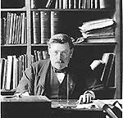
Translated: Book of the Dead

Remnant Egyptians

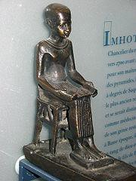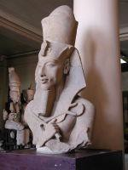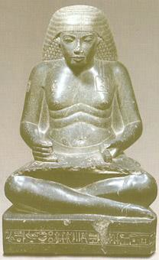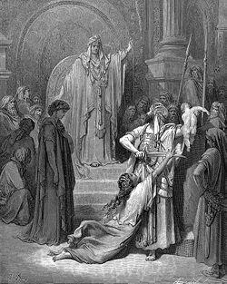

Imhotep
C 2650-2600 BC
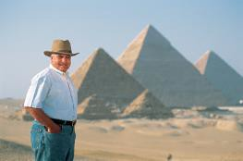
Chancellor under Pharaoh Djoser Polymath Possibly Joseph
Pharaoh Akhenaten Amenhotep IV
1353-1336 BC
Monotheistic worship
Of Aten
Wife: Nefertiti Pharaoh
after Exile
Contemporary Scribe of Amenemope 1200 BC
“Instructions of
Amenemope”
Solomon
Reign: 967-938 BC
3rd King of United Mon. Son of David and Bath.

Zahi Hawass 1947-Present Sec Gen of Supreme Council Of Antiquities. Sesheshet
A soft answer turns away wrath, but a harsh word stirs up anger. Pr 15:1 Blessed is the man who walks not in the counsel of the wicked…Ps 1:1

Remnant Babylonians
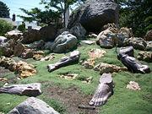
- The Wise Men, Magi or astrologers, were from Babylon.
- Prophecy of 70 Weeks (Dn 9:24-27) written by Daniel
  - Daniel steps forward to interpret Nebuchadnezzar’s dream
  - Nebuchadnezzar made Daniel head of the astrologers
  - Some of these astrologers came to know Yahweh

- Balaam confronted Balak, the king of Moab
  - Balaam hailed from Pethor on the banks of the Euphrates (Iraq: Nu 22:5; Dt 23:4)
  - Balaam’s Prophecy: There shall come forth a star out of Jacob, and a sceptre shall rise out of Israel …Numbers 24:17
Gilgal Sculpture Garden: SLC, UT

- Star
  - “we saw His star in the east” Mt 2:2b
  - the star, which they had seen in the east, went before them, until it came and stood
over where the Child was. And when they saw the star, they rejoiced exceedingly with great joy.
  - Personal, appears & disappears, E to W,
N to S, and hovers: therefore Shechinah Glory

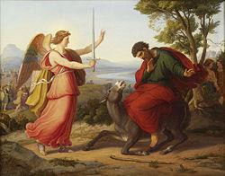
Balaam: Gustav Jaeger, 1836

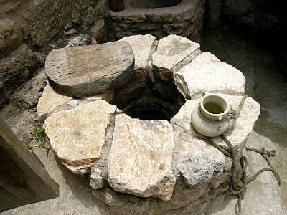
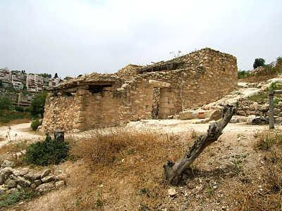
House in Nazareth Well in Nazareth

Chinese Flood Legend
Fa-He (Noah) escaped the Flood which was sent because man rebelled against Heaven. He was accompanied by his wife, three sons, and three daughters.
Ref: Halley’s Bible Handbook, 25 Ed, Zondervan, 2000; p 97

The above legend comes from Chinese tradition and is not derived from the work of C. H. Kang or other Christian etymologists.

Chinese Border Sacrifice

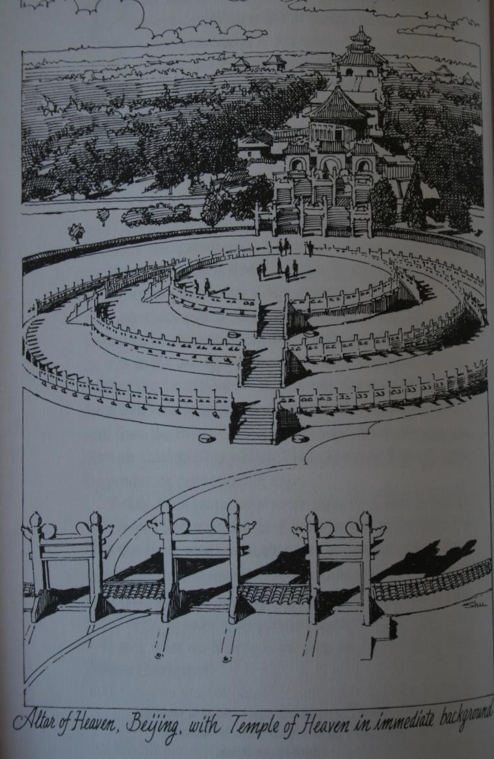
Hall of Prayer, Temple of Heaven, and Altar of Sacrifice
- Ceremony from 2205 BC to 1911
- Situated at East Gate to the Forbidden City
- Only the emperor offered the sacrifice
- Unblemished bullocks and lambs used in sacrifice
- Confucius (551-479 BC) knew not the origin
- What did the sacrifice represent?
- Who was their God?
Heavenly
+

Emperor
=
Shang Ti
Early Oracle Bone Engraving

  - Ref: Nelson & Broadberry, Genesis and the Mystery Confucius Couldn’t Solve, CPH, 1979, p12
  - Note: In Cantonese ShangTi becomes ShangDai

Names of God by Groupings

- YHVH —LORD, Jehovah, hwhy
- Elohim or El —God or god
- Adon or Adonai —Lord or lord

- YHVH Elohim —LORD God (KJV)
- Adonai YHVH —Lord GOD (KJV)

- YHVH Tzvaot—YHVH of Hosts
- YHVH Yireh—YHVH will Provide
- YHVH Rophecha—YHVH Your Healer
- YHVH Nisi—YHVH My Banner
- YHVH Mekadischen— Your Sanctifier
- YHVH Shalom—YHVH is Peace
- YHVH Roi—YHVH My Shepherd
- YHVH Tzidkeinu—Our Righteousness
- YHVH Makeh—YHVH Smites
- YHVH Shamah—YHVH is There
Ref: Fruchtenbaum, A. G. 1983, #47
- El Shaddai —God Almighty (48) Ge 17:1
ydv la
- El Elyon —The Most High God
- El Olam —The Everlasting God
- El Roi —The God of Sight
- El Gmulot —God of Recompense

- King, Shield, Lawgiver, Judge, Rock, Fortress, Tower, Deliverer, Shepherd, Husband, Husbandman, Redeemer, Father, Creator, The Holy One of Israel, The Mighty One

New Testament:
- theos, kurios, Father, Son, Holy Ghost, despoteis, logos, hupsistos, pantokrator, King, Potentate, Creator, Shepherd, Bishop

- Note: Byzantine icons represent Jesus as Pantocrator seated on his heavenly throne.

Chronology
4004 BC Adam Created {Ref: James Usher}

1656 Adam (930) ------------
Lamech (777) --------------------
56 ---------------120-Year Warning-----------
------------------------ Noah (500): Shem, Ham, Japheth

2348 Flood, Noah (600) -
100
2248 Dispersion, Babel, Shinar, Peleg-----------------------------------------------
43 ( great + division + west + walking )

2205 Hsia Dynasty, Sacrifice ---------------------------- -------------------------

327
Job

1921 Abram leaves Haran at age of 75-------------------- Noah (950) Ishmael born to Abram at age of 86
Isaac born to Abraham at age of 100

1998 Noah Dies
1848 Shem Dies at age of 600
1821 Abraham Dies at age of 175
714
- -

1491 Exodus: “Moses wrote”: Bereshit, Shemot, Vayikra, Bamidbar, Debarim, Ps 90 (Ex 24:4, Nu 33:2, Dt 31:9, 22)

Praise vs Denigration

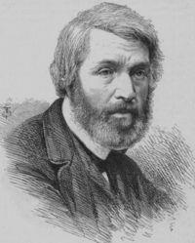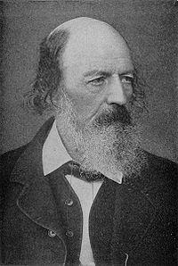

Thomas Carlyle 1795-1881
Scottish Satirical Writer, Essayist and Historian Calvinist
“There is nothing written, I think, in the Bible or out of it, of equal literary merit.”

Alfred Lord Tennyson 1809-1892
Poet Laureate U.K. Christian & Pantheistic Leanings
After Shakespeare he is the most quoted English author. “Job is the greatest poem of ancient or modern times.”
Christine Hewitt c 1970-2006
Jamaican Journalist & Entertainer TV Host & Shock Jock of “Man Talk” “The Bible was the worst book ever written”. She did not believe or follow Christianity.
Ironic and Tragic Death

References for Chinese Etymologists
  - Kang, C.H. Genesis and the Chinese. Hong Kong, Independent Printing, 1950

  - Kang, C.H. and Nelson, Ethel R. The Discovery of Genesis, St. Louis, Concordia Publishing House, 1979

  - Nelson, Ethel R. and Broadberry, Richard E. Genesis and the Mystery Confucius Couldn’t Solve, CPH St. Louis, 1994

Ideograph: F - - - -

Water + (8 + Holding Hands + Earth) Total = F - - - -

Ref: Kang 1979 p 98. Confirms F---- over entire Earth.

Rule of Deductive Etymology
Elements Concept

Theology Knowledge World View
Series of Words Final Idea
Radicals (214) Ideograph
Drawing Pictograph

Man + Money

Double Gate
Tell #1
Tell #2
Tell #3
Steward Gamble Riches, Power

Hazor Megiddo Gezer

World View Evokes
Prof. Yadin Josh 11:1
I Ki 9:15

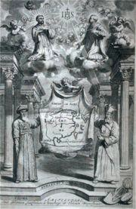
Ideograph: FLOOD

Francis Xavier 1552
C.H. Kang 1950
The Christ Religion
Ignatius Loyola 1556

Water + (8 + Holding Hands + Earth) Total =

Xu Guangqi
Matteo Ricci 1582

FLOOD

Ref: Kang 1979 p 98.
Biblical knowledge needed for interpretation.

The Lord of Heaven Religion
  - Top down conversion
    - Princes, Courts, Scholars
  - Secular knowledge
    - Math, Hydraulics, Astronomy
  - Gifts
    - Clocks, Telescope, Harpsichord
  - Catholicism
    - Common Heritage, Gospel
  - Suppressed
    - Bankers, Landlords, Papal Fealty

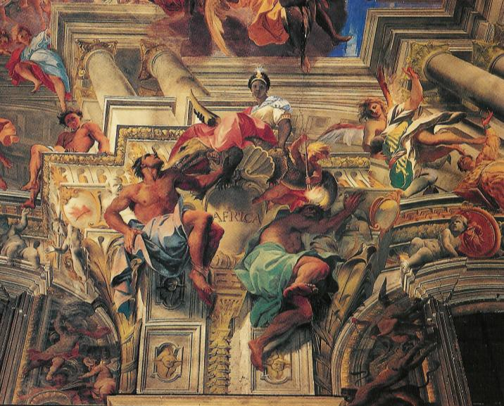
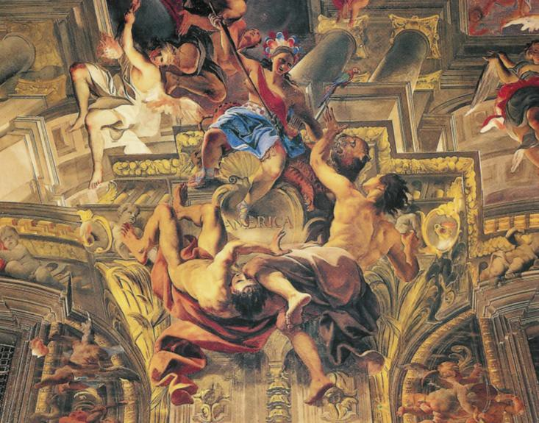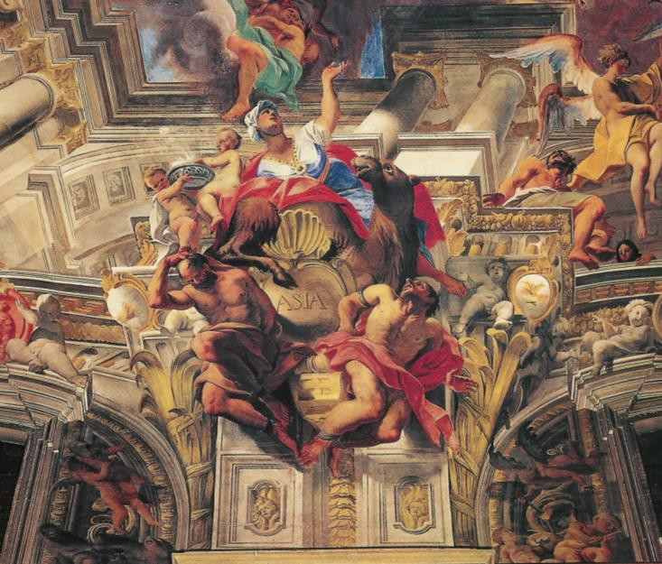Jesuit Plan for World Conquest
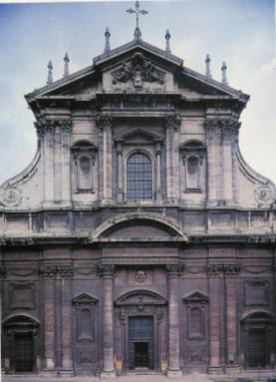
Church of St. Ignatius Of Loyola –1650

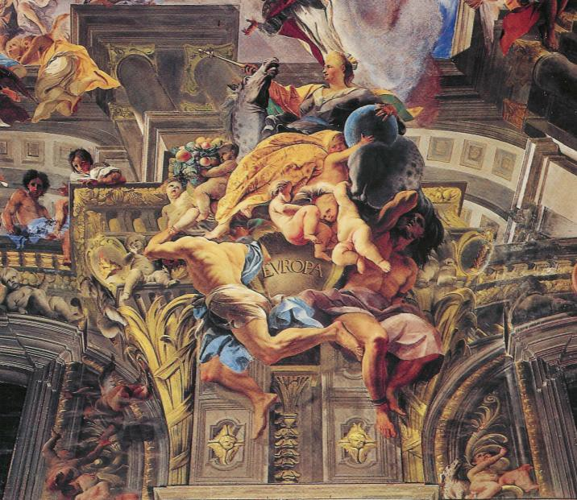
Reformation lost 5M S America gain 9M China gain 1M 1920 China gain 4M 1949

Peter of Ghent alone Converted 1M 6000 in one day

Ideograph: Boat

Eight + Mouths + Alive + Container = Boat

Ref: Kang 1979 p 95. Confirms Biblical account.

Ideograph: Tower

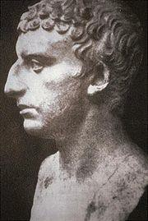
Josef ben Matityahu Titus Flavius Josephus 37-100 A.D.
Historian & Priest from J.

[(Mankind + 1 + Speech) United+ Grass] Undertake + (Clay Brick +Grass) Reinforced Brick = Tower

Ref: Kang 1979 p 106. New Knowledge.
Josephus: Antiquities i, 2:3 Why Brick?

Ideograph: Garden
Garden: Home of the first lords of the Earth

Mountain Mountain Fountain + Mtn

10 Now a river flowed out of Eden to water the garden; and from there it divided and became four rivers. 11 The name of the first is Pishon; it flows around the whole land of Havilah, where there is gold. 12 The gold of that land is good; the bdellium and the onyx stone are there. 13 The name of the second river is Gihon; it flows around the whole land of Cush. 14 The name of the third river is Tigris; it flows east of Assyria. And the fourth river is the Euphrates.
  - Genesis 2:10-14 NASU
  - Ref: Kang 1994 p 51, 170. {Tigris = Hiddekel} New Knowledge

New Knowledge

Pictograph & Ideograph: Fire & Light

Fire: Light:
Ref: Kang 1979, p 42

And the man and his wife were both naked and were not ashamed. Genesis 2:25 NASU

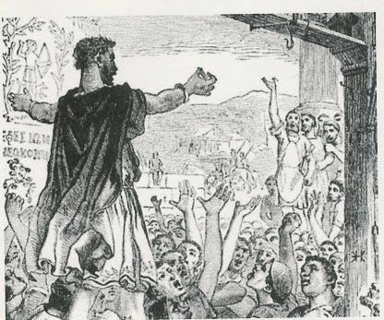He said, " I heard the sound of You in the garden, and I was afraid because I was naked; so I hid myself.“ Ge 3:10

Herod Agrippa I Antiquities XIX 8:2
Acts 12:20-23

  - Bless the LORD, O my soul!
  - O LORD my God, You are very great;
  - You are clothed with splendor and majesty,
  - Covering Yourself with light as with a cloak, --Psalm 104:1-2 NASU

Moses did not know that the skin of his face shone because of his speaking with Him. Ex 34:29 NASU

Royal Apparel = Silver Garment Bendlerblock
“It may be that they were clothed in the ethereal light of God as Jesus was when He was transfigured (Mark 9:3) and that that light vanished when sin entered—but it will one day clothe the redeemed (Rev 3:4; 21:23).” Ref: Halley’s Bible Handbook, 25 Ed, Zondervan, 2000; p 91

  - God created man in His own image, in the image of God He created him; Genesis 1:17 NASU

Ideo-Pictographs: Visit & Think

Before Fall After Fall

To VisitB To ConsultB
(See + God + Creator) (God + His Presence + Man) One who had created
To Think, Meditate, PrayU
(Married Couple Outside Garden) Alone + God

Ref: Kang 1994 p 57, 85. Confirms Biblical Account.

Ideo-Pictographs: Gate, Ask, Hear, Fiery, Evening
Chung Li

Gateo Gateo EveningB Asko HearS Fieryo
(at gate) (at gate) [Ge 3:24]
[Ex 25:22]
Thru Gate + Under Moon + (Couple + at Tree) Picking = Evening

Subscripts: O (oracle bone engraving)
B (bronze engraving)
S (cylindrical seal impression) U (mixture)

Ref: Kang 1994 p 82, 86, 173 New Knowledge

Ideographs: Sacrifice, Animals, Righteous

SacrificeU | SacrificialS | Righteous
Conjoined Hands  Outside Garden + God  [Hebrews 13:12] | Animals  Ox, Sheep,  Unblemished | Me + Lamb
Spear
New knowledge at Gate. Confirmation. Confirmation. Explains Altar of Sacrifice.

Ref: Kang 1994 p 86, 87; 1979 p 83.

Ideographs: Judge, Spirit

Ideograph | Judge | Spirit
 | (Words + Lamb) | (Heaven + Cover + Water) Rain +
Scripture | [John 5:22] | 3 Persons + Worker of Miracles
History | {En 69:39}
Mazzarot {Taurus: Pleiades}
He sat upon the throne of his glory; and the principal part of the judgment was assigned to him, the Son of Man. Sinners shall disappear and perish from the face of the earth, while those who seduced them shall be bound with chains for ever. En 69:39
{Gemini: Apollo}

Ref: Kang 1979 p 88, 39. Unified Theory of Primal Revelation
Bullinger 1967 p 121, 138

Ideograph: Create

(Dust + Breath + Alive) Talk + Walking = Create

Biological Age?
Ref: Kang 1979 p xiii + 41 Confirms Biblical Account.

Ideographs: Tempter, Beginning

Tempter Beginning

(A secret man alive in the garden) Two + adults = Beginning Devil + under cover + two trees =

2

3

4

8

5
Tempter
10

Ref: Kang 1979 p 3-4, 48 Confirms Biblical Account.

Ideographs: Water, Eternal

Water Eternal
(Living Water) (Anointed Water) (Dedicated Water)

Ref: Kang 1979 p 118 Biblical Philosophy

Ideographs: Flesh, Palace

Flesh
(Enter + Border + Person)
Ge 2:22

A Chinese man will sometimes refer to his wife as his inner man.

Ref: Kang 1979 p 46-47 Confirms

Palace
(Conjoined Pair + Roof)

A man shall leave his father and his mother and shall cleave to his wife; and they shall become one flesh. Ge 2:24

Ref: Kang 1979 p 48

Ideograph: Paradigm

Example, Paradigm, Pattern, Exemplar, Way of Life Tree + Lamb + Eternal

Ref: Kang 1979 p 119 Biblical Philosophy

pantoxravtwr yDv
…He did not leave Himself without witness…
- Acts 14:17a NAS

19 For the truth about God is known to them instinctively. God has put this knowledge in their hearts. 20 From the time the world was created, people have seen the earth and sky and all that God made. They can clearly see his invisible qualities--his eternal power and divine nature. So they have no excuse whatsoever for not knowing God. –Romans 1:19-20 NLT

Behold, I send you out as sheep in the midst of wolves; so be shrewd as serpents and innocent as doves. Matthew 10:16 NAS

Almighty

References
  - Kang, C.H. Genesis and the Chinese. Hong Kong, Independent Printing, 1950

  - Kang, C.H. and Nelson, Ethel R. The Discovery of Genesis, St. Louis, Concordia Publishing House, 1979

  - Nelson, Ethel R. and Broadberry, Richard E. Genesis and the Mystery Confucius Couldn’t Solve, CPH St. Louis, 1994

  - Bullinger, E.W. The Witness of the Stars. Grand Rapids, Kregel Publications, 1967 (1893)

  - Halley, H.H. Halley’s Handbook. 24th and 25th Editions. Grand Rapids, Zondervan, 2000

  - Josephus, Flavius. The Complete Works of Josephus. Grand Rapids, Kregel, 1981

  - Morris, Henry M. The Biblical Basis of Modern Science. Grand Rapids, Baker Book, 1984

  - Budge, E.A. Wallis. Translation of The Egyptian Book of the Dead. N.Y., Dover, 1967 (1899)

  - Rolleston, Frances. Mazzaroth. Kessinger Publishing. 1862

  - Seiss, Joseph A. The Gospel in the Stars. Grand Rapids, Kregel. 1972

  - Kennedy, D. James. The Real Meaning of the Zodiac. TBN. 1989

  - Fruchtenbaum, Arnold G. The Names of God #47 ariel.org

  - Missler, Chuck. Signs in the Heavens. Koinonia House
A. G. Fruchtenbaum 1943—
Dispensationalist

  - Banuk, Ron. Mary: Past, Present, and Future. Toronto, Wittenburg Publications, 1999

