Psalm 19 (#38) By Ron Banuk 28 January 2013

Henry M. Morris (1918-2006) once wrote: “The 19th Psalm is one of the most magnificent writings in the Bible and indeed in all literature. As in all the psalms, the structure is poetic as it extols the majesty of creation in its first six verses, followed by the far greater glory of the Scriptures in the final eight. It displays remarkable scientific insight as well as profound spiritual truth.
On the other hand we have Ernst F. K. Rosenmueller (1768-1835) who postulated that the lack of coherence between the two parts of Psalm 19 and their dissimilarity in word and matter meant that the psalm is actually two hymns joined together. Wilhelm M. L. de Wette (1780-1849) later revived Rosenmueller’s argument by pointing out the differences in measure, rhythm, and tone. In 1835, Heinrich G. A. Ewald (1803-1875) wrote: There is no transition from the first to the second part either in thought or language and added that the subject changed abruptly and entirely. He saw Psalm 19 as the amalgamation of two poems.
If a baseball and an aluminum bat were placed on a table, they would be seen to have no relation to each other, other than that they both are manufactured products of the 21st century, unless one understood the game of baseball. Only then could the two objects be related. So what missing fact or event can be found to unify Psalm 19? What did Henry Morris know? His eulogy was either hyperbole or he knew something most do not.
The Book of Psalms occurs within the five wisdom books. The 150 psalms of which David wrote 73 are divided into 21 classifications and 8 groupings in my book Psalms in Clear English. Traditionally, Psalm 19 which is attributed to David has been classified as a creation psalm, but it is really a Didactic or teaching psalm and also and perhaps more importantly a Commandment psalm.
Outline of Psalm 19

Verses 1-4: Heavens
Verses 4-6: Sun
Verses 7-10: Scripture
Verses 11-14: Servant

Read and cogitate the meaning of Psalm 19.

Let’s build the case that Verses 1-6 show God’s revelation in the heavens and verses 7-14 show God’s revelation in Scripture.

Pre-Mosaic Revelation

We know that Moses began to write (Ps 90, Ex 24:4, Nu 33:2, Dt 31:9, 22) in 1450 BC or about 2500 years after Adam was created. Was there any revelation before Moses? We have the Protoevangelium in Genesis 3:15 when God addressed Satan within Adam and Eve’s hearing in the middle of the Adamic Covenant. This was the second of the seven times Satan was judged. Later we have Jesus Christ as the Angel of the Lord appearing to Abraham 2100 years after creation (Ge 16:10). But was there any revelation between those events? Were there prophets?

Pre-Mosaic Prophets

In Luke we read: As He spoke by the mouth of His holy prophets, who have been since the world began, (Luke 1:70 NKJV). Again in Acts we read: whom heaven must receive until the times of restoration of all things, which God has spoken by the mouth of all His holy prophets since the world began (Acts 3:21 NKJV).

So who were these holy prophets since the world began? The earliest prophet designated as such in the OT is Abraham. In this account, Abimelech the king of Gerar was told in a dream by God: Now return the man's wife (Sarah), for he (Abraham) is a prophet, and he will pray for you and you will live. But if you do not return her, you may be sure that you and all yours will die (Ge 20:7 NIV)." However, Jude in the NT quotes Enoch (Enoch ii) as saying: ¹⁴ Enoch, the seventh from Adam, prophesied about these men: "See, the Lord is coming with thousands upon thousands of his holy ones ¹⁵ to judge everyone, and to convict all the ungodly of all the ungodly acts they have done in the ungodly way, and of all the harsh words ungodly sinners have spoken against him (Jude 1:14-15 NIV)." Reading the Book of Enoch as a history book the way we would read Josephus, we learn that Enoch wrote down his prophecies and gave them to his son, Methuselah.

Finally there is Melchizedek (Ge 14:18-20). There is no doubt that Melchizedek is a priest, but what most commentators miss is that he is also a prophet. Why—for two reasons. First he brought Abram a message from God. Secondly he is a Type of Christ as shown in Hebrews Chapters 5-7; and Jesus Christ, who had the role of prophet while he was on Earth, has now the role of great high priest in Heaven, and when he returns to Earth will have the role of king.
Melchizedek would be an incomplete Type if he were only priest and king.

In Jewish literature, Melchizedek was in actuality Shem, the son of Noah. Noah became the father of Shem when he was 500 years old (Ge 5:32). Noah too was a prophet. Noah was told by God that the Earth would be deluged by a flood (Ge 6:7). After the Flood, the Lord told the Earth through Noah to “be fruitful and increase in number and fill the Earth” (Ge 9:1). The

Noahic covenant was established with Noah (Ge 9:17). Noah was told that a flood would never again destroy the Earth (Ge 9:13; Is 54:9). This proves that Noah was indeed a prophet and traces a direct line from Abraham to Melchizedek to Noah to Methuselah to Enoch to Adam.
Actually Noah was born well before Adam died, so the human race always had at least one prophet receiving word from the Lord.

Astronomy

Most historians ascribe the origin of astronomy to the Chaldeans. Abraham was a Chaldean. Josephus (37-100 AD) writes that Abraham taught the Egyptians mathematics and astronomy. The Greek historian, Philo (20 BC-50 AD), wrote that Terah studied astronomy under Noah and taught that subject to his son, Abram. Josephus also claims that astronomy was invented by Seth, Adam’s son.

Since the Mazzaroth or Zodiac forms an endless circle of 12 constellations in the heavens, it is nearly impossible to determine what begins and what ends each year. Today most people assume Aries, however, Frances Rolleston points out that when Adam was created on 4004 BC, the Sun at the summer solstice was 1-degree within Virgo. This is an amazing coincidence!
This is supposition, but it would be plausible that God had described the sign of Virgo to Adam because his wife knew the child would be divine (Ge 4:1).

Was This Revelation Given to the Entire World?

Was this revelation by the prophets made clear to the whole world? ¹⁸ The wrath of God is being revealed from heaven against all the godlessness and wickedness of men who suppress the truth by their wickedness, ¹⁹ since what may be known about God is plain to them (men), because God has made it plain to them (men). ²⁰ For since the creation of the world God's invisible qualities
— his eternal power and divine nature — have been clearly seen, being understood from what has been made, so that men are without excuse (Romans 1:18-20 NIV). What is it that would induce a non-Christian to clearly see the eternal power and divine nature of God? Is it happening today among say atheists? I don’t think so. So what was it missing?

In the Gospel of Grace written by Paul we read: ¹⁶ But not all the Israelites accepted the good news. For Isaiah says, "Lord, who has believed our message (Is 53:1)?" ¹⁷ Consequently, faith comes from hearing the message, and the message is heard through the word of Christ. ¹⁸ But I ask: Did they not hear? Of course they did: "Their voice (line) has gone out into all the earth, their words to the ends of the world (Romans 10:16-18 NIV)." Here Paul says that even though New Testamental faith came via the voice of Jesus Christ, a previous “voice” (line) had gone out into the whole world prior to the time of the missionary movement of God’s disciples. What was that message and where was it contained?

Who did the Naming?

Who named the animals? Before Eve was created, God paraded all his animals before Adam. ¹⁹ Now the Lord God had formed out of the ground all the beasts of the field and all the birds of the air. He brought them to the man to see what he would name them; and whatever the man called each living creature, that was its name. ²⁰ So the man gave names to all the livestock, the birds of the air and all the beasts of the field (Genesis 2:19-20 NIV).

Now the question is Who named the stars? He determines the number of the stars and calls them each by name (Psalms 147:4). So God not only named the stars, but he also numbered them. In Isaiah’s reservoir of Biblical knowledge we read further: ²⁵ "To whom will you compare me? Or who is my equal?" says the Holy One. ²⁶ Lift your eyes and look to the heavens: Who created all these? He who brings out the starry host one by one, and calls them each by name.
Because of his great power and mighty strength, not one of them is missing (Isaiah 40:25-26 NIV). Here God is seen to create, number (one by one), and name (call) each star.

Why was Adam given the responsibility to name the animals, but not the stars of God’s creation? Why does God boast of naming the stars?—because they are more than just stars. Obviously God had a special purpose for the stars. What was that purpose?

Purpose for the Stars

The three purposes for the stars is given early in Genesis: ¹⁴ Then God said, "Let there be lights in the expanse of the heavens to separate the day from the night, and let them be for signs and for seasons and for days and years; ¹⁵ and let them be for lights in the expanse of the heavens to give light on the earth"; and it was so. ¹⁶ God made the two great lights, the greater light to govern the day, and the lesser light to govern the night; He made the stars also. ¹⁷ God placed them in the expanse of the heavens to give light on the earth, ¹⁸ and to govern the day and the night, and to separate the light from the darkness; and God saw that it was good. ¹⁹ There was evening and there was morning, a fourth day (Genesis 1:14-19 NASU).

So there are three reasons for the stars. First of all, there is no way to tell time without some repeating oscillatory device. With a repeating device like planetary motion, time becomes relative to those motions. Otherwise there would be no way to determine time. [As a side task, try to determine the definition of “time”.] Here seasons can be taken to mean an actual annual season or the generic term meaning a time for a series of events as in Ecclesiastes: ¹ There is a time for everything, and a season for every activity under heaven: ² a time to be born and a time to die (Ecc 3:1-2 NIV). Finally the stars are to be signs. The NIV has a false translation here when it says: “signs to mark the seasons, days, and years”. This is a whitewash of the word “sign” and is often done when the translators do not understand a particular text and try to make it explainable in simple language. The problem here is that it can only be explained according to how the translator understands it. The Bible uses the word “sign” in a distinctive manner:

- Moses said that the swarm of flies would be a sign to the Egyptians (Exodus 8:23).

- Isaiah told Hezekiah, king of Judah, that the 10-step retrograde motion of the sundial would be a sign (2 Kings 20:9).

So then a sign is some meaning beyond the inherent nature of an object. Jewish apologists argue that the Hebrew word almah in Isaiah 7:14 has the meaning of “young woman”. Textually this is possible, but if it were true, then it would not be a “sign” as posited in the Biblical text: Therefore the Lord himself will give you a sign: The virgin will be with child and will give birth to a son, and will call him Immanuel (Isaiah 7:14 NIV).

What are the Signs in the Stars?

The Bible says: “The heavens declare the glory of God”. So, the first question is: What is the glory of God or in whom is the glory of God personified?

and every tongue confess that Jesus Christ is Lord, to the glory of God the Father (Philippians 2:11 NIV).

The city does not need the sun or the moon to shine on it, for the glory of God gives it light, and the Lamb is its lamp (Revelation 2:23 NIV).

The Son is the radiance of God's glory and the exact representation of his being, sustaining all things by his powerful word (Hebrews 1:3a NIV).

For God, who said, "Let light shine out of darkness," made his light shine in our hearts to give us the light of the knowledge of the glory of God in the face of Christ (2 Corinthians 4:6).

So then, if God’s signs are in the stars and they show the glory of God, then they must foretell of Messiah!

Does the Bible mention stars?

Astronomically, the elements of the heavens are divided into individual stars, groupings of stars called constellations, and the grouping of constellations called the Zodiac or Mazzaroth in Hebrew.

Individual Stars in the Bible

Metaphorically, the word “star” means angel as in Revelation: The mystery of the seven stars that you saw in my right hand and of the seven golden lampstands is this: The seven stars are the angels of the seven churches, and the seven lampstands are the seven churches (Revelation 1:20 NIV). The fall of Satan as told in Isaiah begins as follows: "How you are fallen from heaven, O Lucifer, son of the morning! How you are cut down to the ground, You who weakened the nations (Isaiah 14:12 NKJV). In Latin the word lucifer meant Venus as the morning star. Since

the Biblical metaphor represented Satan, the astronomical name of a star became one of the proper names of Satan. That is why people involved in witchcraft will attest that Satan’s name is not Lucifer, because it was conferred on him by Christians.

Another individual star found in the Bible is the Sun. In Genesis it is used astronomically as follows: Now as the sun was going down a deep sleep fell upon Abram (Genesis 15:12a NASU). It is also used metaphorically to refer to the Lord God.
The Lord God is a sun and a shield (Psalm 84:11a)
His glory from the rising of the sun (Isaiah 59:19b)
The sun of righteousness will rise with healing in his wings (Malachi 4:2a)
The Bridegroom coming out of his chamber (Psalm 19:5) Jesus’ face “shining like the sun” (Matthew 17:2)

Constellations in the Bible

Great Bear (Arcturus or Ursa Major), Orion, Pleiades [within Taurus] (Job 9:9) The Chambers of the South [Scorpio opposite Taurus] (Job 9:9)
Pleiades, Orion (Job 38:31) Great Bear (Job 38:32) Pleiades, Orion (Amos 5:8)
The Twin Brothers = Gemini as the name of a ship [Castor and Pollux] (Acts 28:11
By his Spirit, He garnished the heavens; his hand formed the crooked (fleeing) Serpent [Hydra the first decan in Leo] (Job 26:13 KJV).

Zodiac

Can you bring forth Mazzaroth in his season (Job 38:32 NKJV)?

The answer is obvious. Only God can create the Mazzaroth. Job, whose uncle was Peleg (Ge 10:25-26) when the Earth was divided at the Tower of Babel, knew this.

See also Mazzaloth in 2 Ki 23:5b translated as “planet”. Note that Massaloth is the new English transliteration of the Hebrew word. The singular is Mazzal.

When Job writes that by his Spirit he garnished the heavens, he means that God divided up the visible heavens into the known constellations. As proof of this, note the parallel theme at the conclusion of the sentence: his hand formed the crooked Serpent. Forming or designating Hydra was an example of garnishing the heavens.

Biblical Terms that Originate in the Stars

The Lamb (Ge 22:7 First Use) [NT: Lamb of God (Jn 1:29, 36)]

Isaac said: Where is the lamb for the burnt offering?

Constellation Aries: Taleh (Hebrew), Al Hamal (Arabic), Amroo (Syriac)

The Breaker (Micah 2:13) The Breaker goes up before them.

Third Deacon to Aries: Perseus (Heb), Kar Knem (Egy), Perses (Gk), Perseus (Ro)

The Branch (Is 4:2) In that day, the branch of the Lord will be beautiful and glorious.

Star in First Deacon to Taurus called Orion: Betelguez (Arabic)

Desired One (Haggai 2:7) The desire of all nations shall come

Name of infant in First Deacon: Coma (Hebrew)

Sheepfold (John 10:1) He that entereth not by the door into the sheepfold but climbeth up…

Second Deacon called Ursa Major in Cancer: El Acola (Arabic)

Redeemer (Job 19:25) I know that my Redeemer lives.

Name of third Deacon to Gemini: Procyon (Hebrew)

Dragon (Rev 12:9) The great Dragon was hurled down—that ancient serpent called the devil or Satan.
Name of the third Deacon in Sagitarius: Ethanin (Hebrew), Dracon (Greek)

Lion (Rev 5:5) The lion that is from the tribe of Judah, the root of David

Name of the constellation Leo: Ariel (Hebrew) Al Asad (Arabic) Leon (Greek)

Pierced (Zechariah 12:10) They will look on me whom they have pierced Name of star in third decan to Virgo: Nekkar (Hebrew)

Summary 1

- Only God can create the Mazzaroth (Job 9:9). Job gives us an example of God creating the sign of Hydra within the Mazzaroth.
- God created, numbered, and named the stars (Ps 147:4; Is 40:25-26).
- These stars were to be for signs, seasons, and time keeping (Ge 1:14-19).
- The signs, not the stars, were to show the glory of God through Messiah (Ps 19:1).
- These signs went forth into all the Earth (Ps 19:4a) and are to be viewed as the Bridegroom coming out to his Bride, those saved.

- There was revelation prior to Moses (Ge 3:15) and an unbroken chain of prophets to tend to the message in the stars (Lk 1:70; Acts 3:21; Jude 1:14-15). Some prophets were Adam, Enoch, Methuselah, Noah, Melchizedek (Seth), and Abraham.
- The imagery in the signs pervades the Bible (Branch, Breaker, Lamb, Desired One, Dragon, Redeemer, Pierced, Lion, Sheepfold).
- So what was that message in the signs that Abraham brought to Egypt; and Frances Rolleston and others rediscovered 3782 (1921 + 1862) years later?

Messiah in the Mazzaroth

Knowing the eight points above, we can now begin our astronomical quest into finding God’s message within the signs of the Mazzaroth.

Background Astronomical History

Most nations in antiquity (Chaldeans, Babylonians, Egyptians, Persians [Zoroastrians], Chinese, Indians, Greeks, Romans) had 12 constellations within its Zodiac or Mazzaroth. The idea of helper or deacon constellations was maintained by the Persians, Egyptians, and Indians. That makes 48 constellations in toto. Ancient astronomers that were the curators of 48 constellations were Ptolemy, a Greco-Roman from Alexandria (90-168 AD) and Albumazar, an Arabic physician and astronomer (805-885). In 1252, Avicena, and Arab physician and astronomer from Bagdad, presented the names of 1022 fixed stars at a conference in Toledo. So although as many as 4000 stars can be seen with the naked eye, apparently only 1022 were named in the Dark Ages. In 1893, E.W. Bullinger associated 2610 stars with these 48 constellations, but, in fact, only used a fraction of that number in his discussion as found in The Witness of the Stars.

Leading Researchers in the Signs of the Mazzaroth

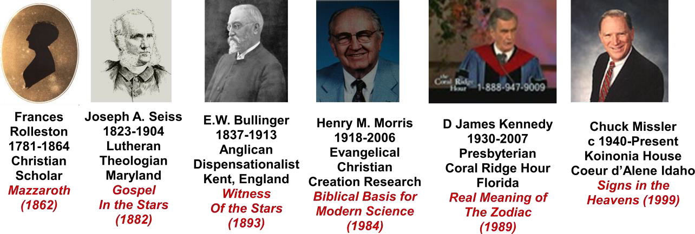

In 1792, Charles-Francois Dupuis (1742-1809) published L’Origine des Cultes which attempted to define the origin of all religions from the constellations in the Zodiac, but no reasons were given for why the constellations were so grouped or named. Frances Rolleston (1781-1864) of Keswick read that book and with her Christian heritage became the first scholar in modern times to explain the origins of the Zodiac in her book Mazzaroth published in 1862. The book was passed over by reviewers in its day but was not ignored by esoteric scholars. Rolleston’s work is not unlike that work of the famous Harvard researcher in astronomy Williamina P. Fleming (1857-1911) who compiled more stellar spectral classifications than anyone else in history.

Twenty years later on the other side of the Atlantic, Joseph A. Seiss (1823-1904), a Lutheran theologian from Maryland used Rolleston’s book as a font to publish The Gospel in the Stars in 1882. Eleven years later, back in Kent, England, E.W. Bullinger (1837-1913), an Anglican Dispensationalist, relied on both previous books to publish The Witness of the Stars in 1893.

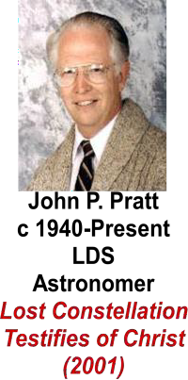
The idea then slept for a century until Henry M. Morris (1918-2006), an evangelical Christian for Creation Research published among his many scientific findings denouncing Evolution his idea of the Mazzaroth in his section on Biblical astronomy in his book The Biblical Basis of Modern Science in 1984.

Immediately after Dr. Henry Morris’ book, D. James Kennedy (1930-2007), a Presbyterian broadcasting on Coral Ridge Hour in Florida published The Real Meaning of the Zodiac in 1989. Chuck Missler (1940-present), a former engineer at Koinonia House in Coeur d’Alene, Idaho wrote Signs in the
Heavens in 1999. John P. Pratt (1940-present), an LDS chronologist and astronomer, wrote Lost Constellation Testifies of Christ in 2001. I personally became involved after reading The Biblical Basis for Modern Science by Henry Morris.

How Are the Signs Interpreted?

There are four ways to decode the meanings of the signs attached to the Mazzaroth. The four hermeneutical rules are as follows:

- Find the meaning of the names of the 12 major constellations and their 36 decans from the earliest languages.
- Find the meaning of the major stars within the 48 constellations.
- Relate the meanings to Scripture.
- Relate the meanings to the earliest stylized picture (pictograph) of the Mazzaroth.

1: Meanings of the Constellation Names

Sign | Language | Word | Meaning
Aries: | Hebrew | Taleh | lamb
 | Arabic | Al Hamal | sheep
 | Syriac | Amroo | lamb
 | Greek | Krios | ram
 | Latin | Aries | ram
 | Coptic | Tametouris | reign of Ammon
Taurus | Hebrew | Shur | bull
 | Arabic | Al Thaur | bull
 | Coptic | Apis | bull that comes
 | Greek | Tauros | bull
 | Latin | Taurus | bull
Gemini | Hebrew | Thaumin | united or twinned
 | Arabic | Al Tauman | the twins
 | Syriac | Thaumin | united
 | Coptic | Pi Mahi | united
 | Greek | Didumoi | twins
 | Latin | Gemini | twins
Cancer | Hebrew | Sartan | he who holds
 | Arabic | Al Sartan | he who holds
 | Syriac | Sartano | he who holds
 | Coptic | Klaria | cattle folds [sheepfold]
 | Greek | Karkinos | crab meaning holding a possession
 | Latin | Cancer | crab
Leo | Hebrew | Ariel | lion (pluck)
 | Arabic | Al Asad | lion
 | Syriac | Aryo | lion who rends
 | Coptic | Pi-Mentekeon | plucking asunder
 | Greek | Leon | lion
 | Latin | Leo | lion
Virgo | Hebrew | Bethulah | virgin
 | Arabic | Sunbula | who bears (virgin)
 | Syriac | Bethulto | virgin
 | Coptic | Aspolia | station of the desired
 | Greek | Parthenos | virgin

 | Latin | Virgo | virgin
Libra | Hebrew | Mozanaim | scales, weighing
 | Arabic | Al Zubena | purchase, redemption
 | Syriac | Mazatho | scales
 | Coptic | Lambadia | station of propitiation
 | Greek | Zugos | scales
 | Latin | Libra | weighing
Scorpio | Hebrew | Akrab | scorpion, conflict
 | Arabic | Al Akrab | scorpion, wounding
 | Syriac | Al Akrab | scorpion, wounding
 | Coptic | Isidis | attack by the enemy
 | Greek | Scorpios | scorpion, cleaving in conflict
 | Latin | Scorpio | scorpion
Sagittarius | Hebrew | Kesith | archer
 | Arabic | Al Kaus | arrow
 | Syriac | Kesith | bow
 | Coptic | Pi-maere | going forth
 | Greek | Toxotes | archer
 | Latin | Sagittarius | archer
Capricornus | Hebrew | Gedi | kid, cut off
 | Arabic | Al Gedi | kid, cut off
 | Syriac | Gedi | kid, cut off
 | Coptic | Hupenius | station of bearing
 | Greek | Aigokereus | goat
 | Latin | Capricornus | goat, atonement
Aquarius | Hebrew | Deli | water urn
 | Arabic | Delu | water urn
 | Syriac | Delu | water urn
 | Coptic | Hupei Tirion | station of pouring out
 | Greek | Hydrokoeus | pouing forth of water
 | Latin | Aquarius | pouring forth of water
Pisces | Hebrew | Dagim | fishes
 | Arabic | Al Haut | fish
 | Syriac | Nuno | fish
 | Coptic | Pi-cot Orion | fish of he who comes
 | Greek | Ichthues | fish
 | Latin | Pisces | fish, multiplying
In a similar manner, the meanings of the three decans from each of the above constellations can be cataloged. Let’s look at the three decans or minor constellations in Virgo.

Sign | Language | Word | Meaning | Figure
Coma | Hebrew | Subilah | who bears | woman
 | Arabic | Adarah | pure virgin | woman
 | Greek | Astrea | bright | woman
 | Hebrew | Coma | the desired | infant

 | Arabic | Al Awa | the desired | infant
 | Chaldean | Vindemiatrix | the son who comes | infant
 | Greek | Prometheus | the deliverer who comes | infant
Centaurus | Hebrew | Beze | the despised
 | Hebrew | Asmeath | sin offering
 | Arabic | Al Beze | the despised
 | Greek | Chiron | the pierced
 | Latin | Rex Centaurus | the centaur king, the smitten
Boötes | Hebrew | Bootes | the coming
 | Hebrew | Merga | who bruises
 | Arabic | Aramech | being sent forth
 | Arabic | Al Katurops | the branch treading under foot
 | Greek | Arctophylax | the guardian of Arctos

2: Meanings of Major Stars within the Constellations

In Virgo we have Spica once called Al Zamach in Arabic meaning “the branch”. In Coma, the infant is called Zavijavah in Arabic meaning “the glorious one”.
In Coma, the infant is called Al Mureddin meaning “he who shall come down and have dominion”.
In Centaurus, Toliman in the foot means the “heretofore and hereafter”. In Boötes, Arctures means “the guardian keeper”.
In Boötes, Mizar means “the preserver”.

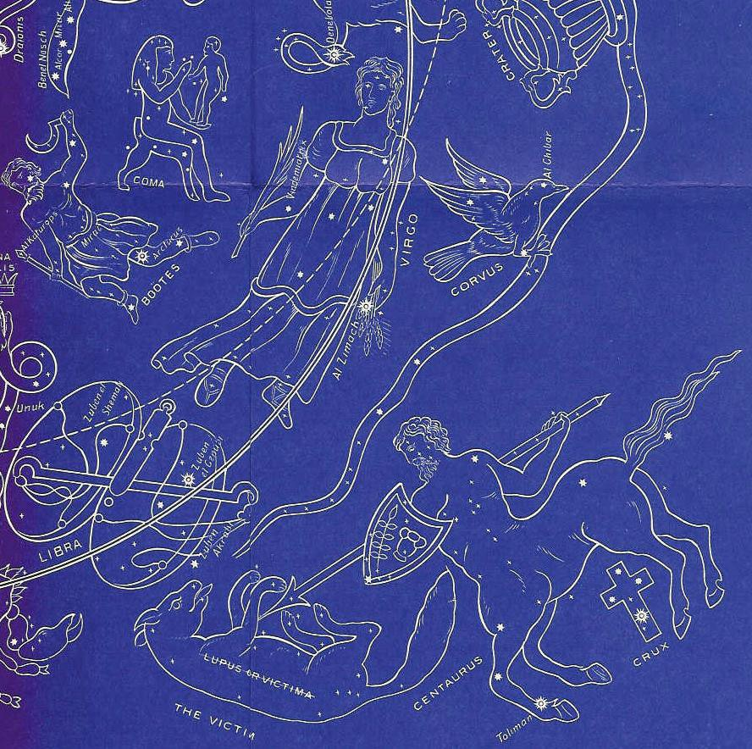
3 & 4: Scripture and Pictograph Combined with 1 & 2

On the ceiling of the temple of Hathor in Dendera, Egypt, there is a pictograph of the Mazzaroth. This sculptured drawing was probably made right after Abraham imparted the signs in the Mazzaroth to pharaoh or sometime after 1900 BC. The relief was removed from the temple in 1820 and put on display in the Louvre. E.W. Bullinger recorded elements from that Zodiac and others to
12

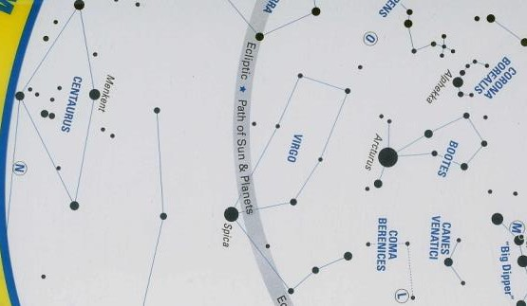
come up with the composite that is presented, in part, here.

Combining the four elements of hermeneutics we see the first sign called Virgo accompanied by the three decans: Coma, Centaurus, and Boötes. Although the 12 signs are chronological from Virgo to Leo, elements of Messiah’s entire life may appear at any time. In her left hand is the Seed from Ge 3:15 representing the First Coming and in her

right, the Branch from Isaiah 4:2 representing the Second Coming. The infant, who is “the desired one” and “the glorious one” is shown in the decan Coma holding “he who shall come down and have dominion”. Although he is in Boötes the Shepherd, the Rock of Israel (Ge 49:24), the “guardian keeper” and “the preserver”, he must first be the “despised sin-offering” as shown anthropologically and zoologically as the dual natured Centaur.

Before we proceed to the second sign, keep in mind that the pictures shown above do not naturally follow by connecting the dots called stars within the constellations. A quick look at the stick figures on a planisphere shown above reveals that the major dots that bound Virgo do not look like or even suggest a virgin. The same is true for Boötes, Centaurus, and Coma Berenices.

Next we go to the sign of Libra with its decans the Cross (crux), the Victim (Lupus), and the Crown (Corona Borealis). The scales ask: What is the price of redemption? The Centaur or Messiah showing his dual nature is slaying himself, the victim. Beneath the Centaur are the four stars comprising the Southern Cross. This constellation is no longer seen at the latitude of Jerusalem and Southern California, but began to dip below the horizon after the death of Jesus Christ. Because the price was paid, the crown (Corona Borealis), which seems out of place at
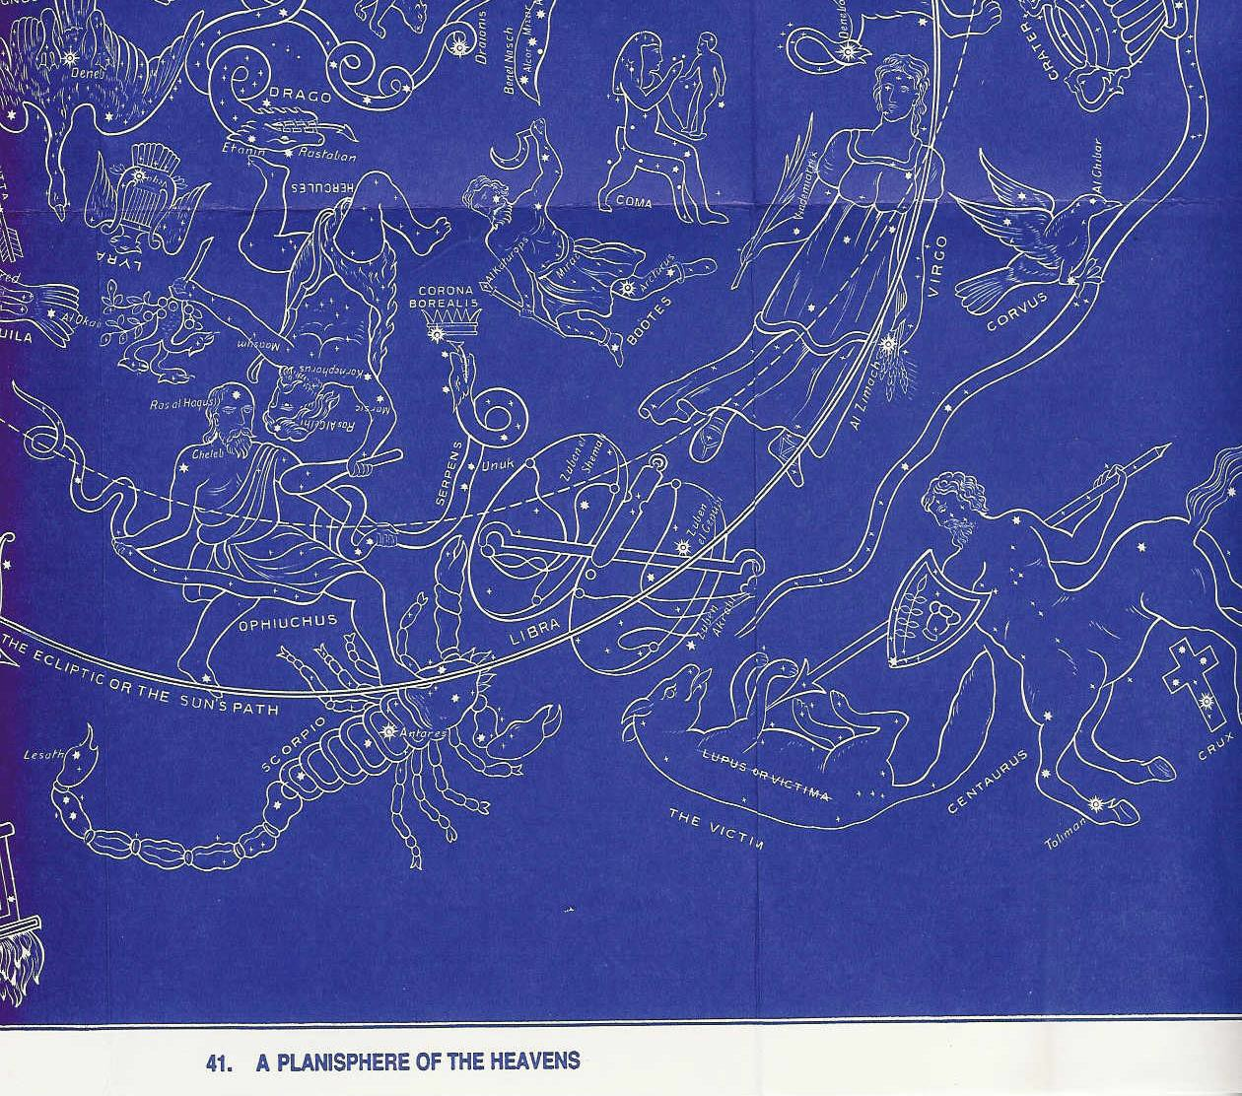
this point, is now possible for Messiah.

The third sign is Scorpio with decans the Serpent, Ophiuchus, and Hercules. Here Ophiuchus as Messiah is at the center of action. He is under attack as the name implies. He is struggling with the Serpent, Satan, who is intent on the Crown (Corona). He is “treading under foot” (Triophas) the head of Scorpion with his right foot. Meanwhile, his left foot is open to attack where he will be struck by Scorpion’s tail at a star in his heel called Saif meaning “bruised”. This brings to

mind the Protoevangelium: He shall bruise you (Satan) on the head, and you shall bruise him (Messiah) on the heel (Ge 3:15). Although Satan as the Serpent is easy to recognize as it has been drawn, it is extremely difficult to recognize in the heavens, which parallels Satan’s presence on Earth. Then we see Hercules as Messiah with the heel of the foot that was bruised over the head of Draco the dragon (Satan). In Arabic, Hercules is called Al Giscale “the strong one”.
The bright star in his head is Ras al Gethi meaning “the head of him who bruises”. The star in his right armpit is Kornephorus meaning the kneeling Branch which is what the Branch is doing. The star in his right elbow is Marsic meaning “the wounding” which he is doing with the club. Another star in his arm is Caiam meaning “punishing”.

The fourth and final chapter to the first of the three books of the Mazzaroth is Sagittarius with its decans: The Harp on Eagle’s wings, the Altar, and Draco. Sagittarius the gracious (Naim) archer and centaur goes forth (Nushata) swiftly (Terebellum). With harp on eagle’s (Nesher), the archer “shall be exalted” (Vega). He sends his arrow (Al Kaus) through the heart of Scorpio. The enemy will be thrust on the burning pyre in the outer darkness thus completing (Al Mugamra) his work. But still the Dragon (Draco not shown here but residing at the north pole) is yet to be
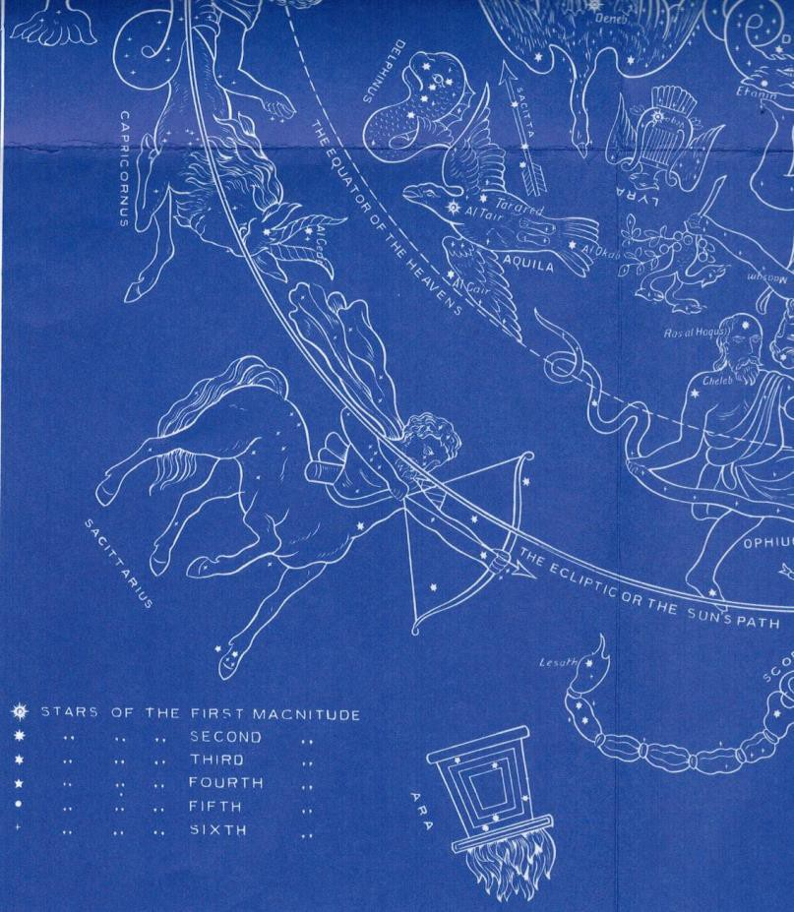
destroyed.

There are three serpents in the Mazzaroth: Draco, Serpens, and Hydra in the south. They each represent Satan and are mentioned at the conclusion of each book.
During the fight, the serpent is hard to see. Only after he is finally defeated with the coming of Leo, Christ the King as the Lion of Judah, is Hydra show in full view in retreat.

Book 1 consists of Virgo (the virgin)

Coma (Madonna and
child)

Centaurus (Mashiach ben Joseph)
Boötes (Shepherd, the Rock of Israel Ge 49:24)

Libra (the scales)
Cross
Victim (Messiah) Crown
Scorpio (the conflict)
Serpent (Satan)
Ophiuchus (Mashiach ben Josef)
Hercules (destroyer of the works of the devil 1 Jn 3:8) Sagittarius (archer shooting Scorpio)
Harp on Eagle’s Wings Altar
Draco (dragon)

Virgo: The virgin bearing the Branch representing the Second Coming and the Seed for the First Coming delivers the desired son (Coma) for all nations. He will be the shepherd and Rock of Israel (Boötes as Ge 49:24) with the crown (Corona) and yet be rejected for his dual nature (Centaur) as the despised (Al Beze) sin offering (Asmeath).

Libra: What is the price for redemption as measured by the Scales (Libra)? The Centaur of dual nature (God and man) must slay (Adom) himself as victim (Lupus) with the purchase price which covers (Zuben al Genubi) on the cross (Crux). The shining (Al Phecca) kingly Crown (Atarah) has been barred to the Serpent (pictograph).

Scorpio: Ophiuchus, the Messiah, bruises Scorpio’s head while Scorpio bruises his heel (Ge 3:15). The name Ophiuchus means “serpent held” from the Hebrew and Arabic Afeichus. He struggles with the Serpent, Satan, intent on the Crown (Is 14:13-14) that through death He might render powerless him who had the power of death, that is, the devil (Heb 2:14 NASU). The Messiah shown as Hercules the strong man (El Giscale) who bruises (Ras al Gethi) is shown wounding (Marsic) with a club (pictograph) in his right hand the devil in his left hand. While kneeling on his right knee, his left foot is crushing Draco’s head

Sagittarius: Sagittarius the gracious (Naim) archer and centaur goes forth (Nushata) swiftly (Terebellum). With harp on eagle’s (Nesher), the archer “shall be exalted” (Vega). He sends his arrow (Al Kaus) through the heart of Scorpio. The enemy will be thrust on the burning pyre in the outer darkness thus completing (Al Mugamra) his work. But still the Dragon (Ethanin), the subtle one (Grumian) is yet to be completely destroyed (Al Waid).

Book 2 consists of Capricornus
Arrow Eagle

Dolphin Aquarius
Fish, Pegasus Cygnus

Pisces

Aries

Band Cepheus Andromeda

Cassiopeia (Enthroned Woman) Cetus (Sea Monster or Leviathan) Perseus

Capricornus: Man will finally become so sinful as to leave no remedy but complete inundation of his entire world. (Ge 7:11-12) Ref: H. Morris

Aquarius: The floodgates of heaven will pour forth waters to cleanse an evil world, but representatives of the land animals will survive to fill the Earth again. Ref: H. Morris

Pisces: From the waters will emerge the true people of God, as God retains His kingly throne despite all the attacks of Satan. (Ge 22:17) Ref: H. Morris

Aries: In the fullness of time, the Seed of the Woman will come, ready to die as the sacrifice for man’s sins, paying the great price to redeem His bride and destroy the works of the Dragon. (Ge 49:10; Dt 18:15) Ref: H. Morris

Book 3 consists of Taurus (Mashiach ben David as the bull)
Orion (Mashiach ben David the warrior) Eridanus (river)
Auriga (shepherd holding a goat) Gemini (Twins: Mashiach ben Joseph & David)
Hare (enemy) Sirius the Prince
Procyon the Redeemer
Cancer (crab retaining its possessions) Bear (Ursa Minor)
Great Bear (Ursa Major) the sheepfold Argo (the ship)
Leo (the Lion) Messiah Returns

Hydra (the fleeing serpent) Crater (the cup)
Corvus (the crow)

Taurus: Messiah the Bull comes forth. As Orion, the coming of the Branch (Betelgeus), he places his left foot over his enemy, Lepus, at the River of the Judge, Eridanus. For all his wrath, he remains the good (Jn 10:11), great (Heb 13:20), and Chief (1 Pt 5:4) Shepherd, Auriga, who holds a female goat (Alioth or Capella) with kids (Gedi) representing the saved. Messiah can be both powerful as a Bull and merciful as the Chief Shepherd. [Note that Zech 10:3 says: I will punish the male goats.]

Gemini: The Twins, Apollo the Judge and Hercules the suffering Servant, come as the mighty (Al Habor) Prince (Canis Major) and the burdened (Gomeisa) Prince (Canis Minor) to defeat the enemy, Lepus.

Cancer: He binds together those the Father has given him (Jn 10:29) into a small sheepfold (Ursa Minor) and a large sheepfold (Ursa Major) from the company of travelers (Argo) in the ark.

Leo: The Lion of Judah will tread underfoot (Regulus) the harlot (Hydra the female serpent) who sits on many waters (Rev 17:1) with her cup of abominations (Crater and Rev 17:4). She and Corvus the Raven will be broken up (Her-na and Rev 18:2) and be tread underfoot (Nu 24:8- 9) by Leo. The Lion of Judah will judge (Denebola and Jn 5:22) and be exalted (Al Giebha and Acts 2:33). Other stars within Hydra indicate she will be put away (Al Phard), abhorred (Al Drian), and pierced for being a deceiver (Minchar el Sugia).

Summary 2

Scripture posits that a story is told by the signs within the stars. By searching out the ancient meanings in the names of the constellations and their individual stars combined with a knowledge of Scripture and the early pictographs of the Mazzaroth, we can determine the rudiments of the revelation given to mankind as early as the days of Adam. That revelation was shepherded continuously by God’s prophets from Adam to Abraham. The message has nothing to do with astrology and everything to do with Messiah. Book 1 tells that he will be born of a virgin, pay the price for redemption, battle against Satan, and die on the cross. Book 3 tells how he, the Branch, will return as the glorified king, save his sheep, and judge the Earth. Book 2 tells of the corruption of the bloodline of the human race by the Nephilim and the destruction of the world by flood. Book 1 is chronologically out of sequence (2,1,3) probably to buoy the hope of antediluvian mankind. The style of the imagery is such that Messiah in his first and second comings takes on many different shapes as he battles Satan who also metamorphoses into many

forms. A constellation with its three decans can flash backward or forward in time probably to emphasize that the first and second comings are by the same person. Only with this knowledge of the signs in the heavens, can Psalm 19 be properly understood and be called “one of the most magnificent writings in the Bible”. So how now can we reclassify Psalm 19?

Appendix

http://www.ronbanuk.com http://www.biblicalastronomy.com http://www.johnpratt.com/items/docs/sidereal/sidereal.html
http://www.horizonenergycorp.com/hpo/constellations/bible.htm

Virgo Promised Seed of the Virgin (Isaiah 7:14) 8/23-9/22 Libra Scales of divine justice for redemption (1 Cor 6:20) 9/23-10/23 Scorpio Sting to be inflicted on the promised seed (1 Cor 15:55-56) 10/24-11/21 Sagittarius The archer who fights the Serpent shall be glorified (Jn 13:31) 11/22-12/21

Capricornus Utter wickedness of mankind (Romans 3:25) 12/22-1/19 Aquarius Destruction of the world by flood (John 7:38) 1/20-2/18 Pisces Emergence of the true people of God (Ge 48:19; Mark 1:17) 2/19-3/20 Aries Sacrifice of the Lamb of God (Rev 5:6) 3/21-4/19

Taurus Coming of the Ram as mighty bull and judge (John 5:22) 4/20-5/20 Gemini One Messiah come twice (Mal 3:1-4; Zech 9:9-10) 5/21-6/21 Cancer Ingathering of the redeemed of all ages (Isaiah 4:5-6) 6/22-7/22 Leo Destruction of the serpent by the king (Rev 5:5) 7/23-8/22

Mazzaroth by Frances Rolleston, 1862, Kessinger Publications The Gospel in the Stars by Joseph A. Seiss, 1882, Cosimo Classics The Witness of the Stars by E.W. Bullinger, 1893, Kregel Classics
The Biblical Basis of Modern Science by Henry M. Morris, 1984, Baker Book House The Real Meaning of the Zodiac by D. James Kennedy, 1989, Coral Ridge Ministries Signs in the Heavens (CD) by Chuck Missler, 1999, Koinonia House
God’s Voice in the Stars by Kenneth C. Fleming, 1927, Loizeaux Brothers, Inc

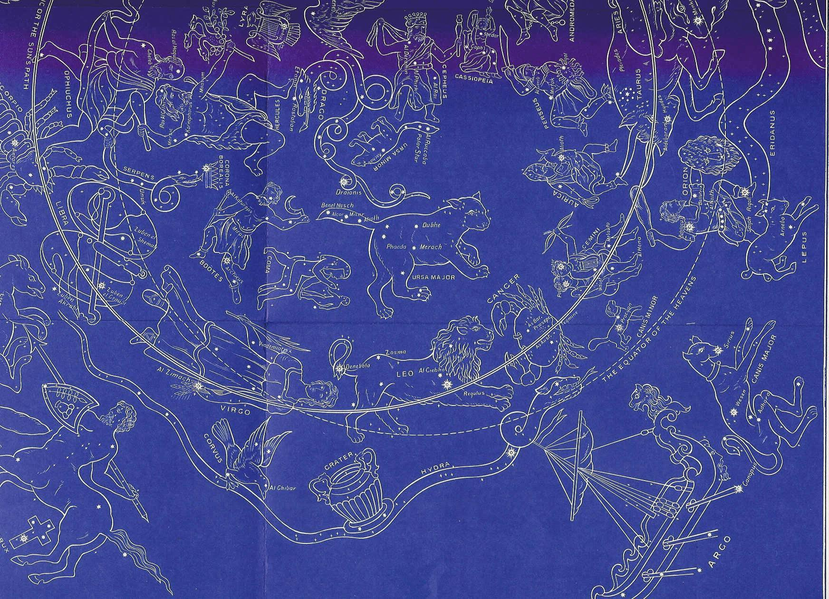

Portion of the Planisphere Presented by E.W. Bullinger in The Witness of the Stars

